Project: Kernel Design Process
Difficulty: Level 1

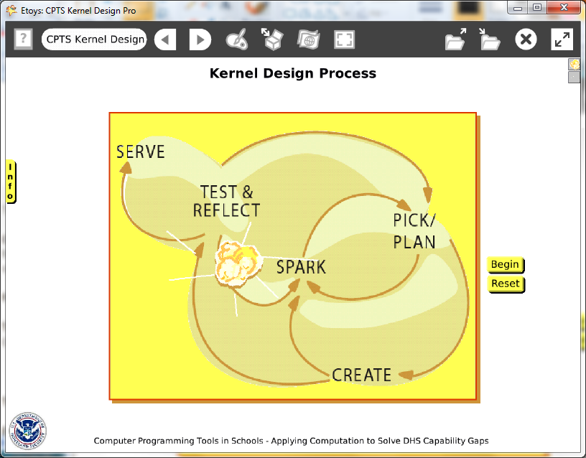

Time: two 45 minute labs

Challenge:
Make a project that demonstrates the growth of an idea as it passes through the stages of a design process. This project uses a kernel of popcorn but any number of objects that grow could be used to good effect in this project.

Programming:
Conditional statements are used to increase the kernel’s size when it is over the location of a word in the graphic. The sparkle uses a conditional test to show if the heading is divisible by 25 and to hide otherwise.
This project uses scripting category tiles to control when a script is ticking or paused. There are no Quick Guides for the scripting tiles; experiment with them and their effects. There are help balloons for each tile.

Things you’ll need to know:
Quick Guides
- Paint Tools/ All
- Halo Handles/All
- Supplies: Text, Add a New Flap
- Object Catalog: Digital Images
- Script Tiles: Forward by, Turn by, Bounce, X and Y Tiles, Scale Factor, Hide and Show, Tests Category
- Menus: Button Fires a Script

Things to think about:
- What advantages and disadvantages are involved in the use of scripts that specify that the kernel increase in size at specific x and y locations? The art of programming is in knowing more than one solution and choosing among them for the effect desired and an efficient process to make it happen.

Extensions:
- Make a script that causes the kernel to bounce against the edge of the playfield and to increase in size with each bounce. Compare the scripts, the effect and the effort involved in making the scripts.
- Is there an easier way to show the development of the idea? Is it as effective?
- Make a script that uses the “obtrudes” tile in a test to affect the change in the kernel’s size.
- Each kind of script has advantages and disadvantages. Discuss

NETS for Students:
http://www.iste.org/standards/nets-for-students/nets-student-standards-2007.aspx
1. Creativity and Innovation: a, b, c,
2. Communication and Collaboration: a, b
3. Research and Information Fluency: a, b
4. Critical Thinking, Problem Solving, and Decision Making: a, b
5. Digital Citizenship: b
6. Technology Operations and Concepts: a, b

CSTA:
CSTA Level II: Objectives and Outline
http://csta.acm.org/Curriculum/sub/CurrFiles/L2-Objectives-and-Outlines.pdf
Level II objectives for middle school students are furthered through studying a programming language well enough that the student is proficient with it. Whether the language is Etoys, StarLogo TNG, or Scratch, it is the ability to use the language to express ideas that is valuable. A student skillful enough to use any programming language to express ideas, solve problems, model behaviors, simulate data, or to educate or entertain is an entitled person in today’s society.
Topics of particular note are:
Topic 2: Problem Solving
Topic 6: Connections between Mathematics and Computer Science
Topic 11: Programming Languages
Topic 13: Multimedia

Common Core Standards Mathematics:
http://www.corestandards.org/the-standards/mathematics
6. EE.2, 6.EE.2c, 6.EE.6, 6.NS.6
8. G.3

Teacher Notes:
Materials: The internet contains a large number of images/examples of the design process as imagined by many designers. A quick survey and discussion will help students start to visualize new ideas and ways to show the process.

Comments: Objects - Scripts – Decisions
Give students time to develop their idea of a design process, it could be to invent a machine or develop a new procedure in topics ranging from medicine to sports.

Example Scripts:

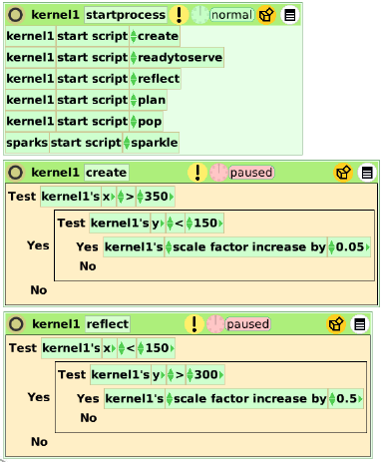

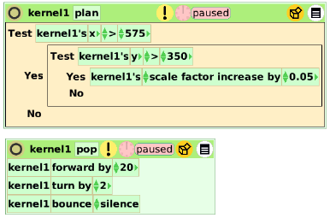

Student Notes:
None provided.

